William Faunce

Carol Roberts

COS 225

02 March 2018

A4WilliamFaunce

Part I

1. public static <T> T peek2(ArrayStack<T> stack) {

ArrayStack<T> newStack = stack;

newStack.pop( );

if(newStack.isEmpty( ))

return null;

else

return newStack.peek( );

}

3

50

10 80 50 40 20

|  |  |
| --- | --- |
| 25 |  |

|  |  |
| --- | --- |
| 10 | null |

top

|  |  |  |  |  |
| --- | --- | --- | --- | --- |
|  | 25 | 10 | 30 | 5 |

0 1 2 3 4

**front: 0 rear: 4**

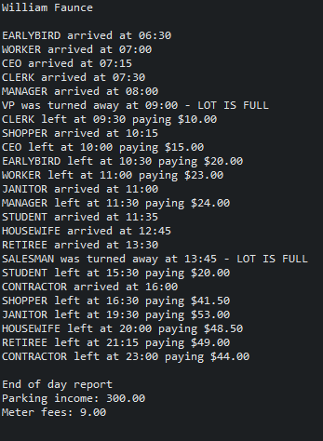Screenshots:

